**Open Source Tools for Data Science**

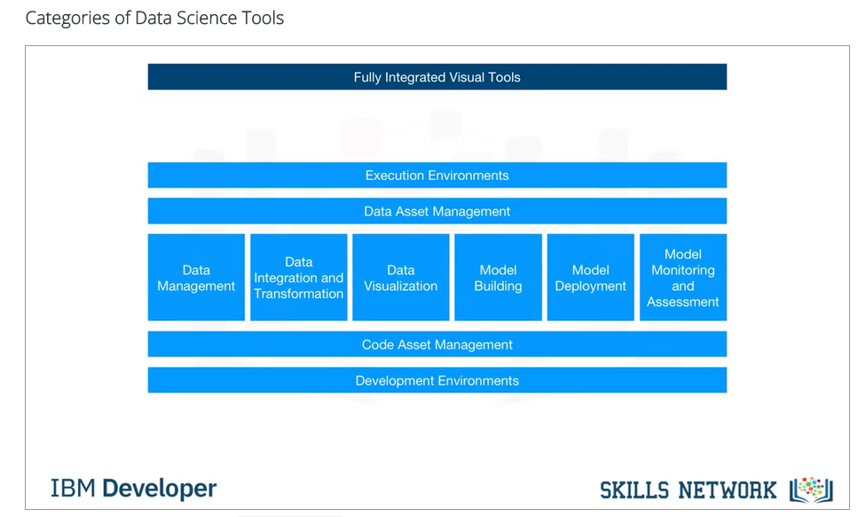

1. **Data Management** is the process of persisting and retrieving data.
2. **Data Integration and Transformation, often referred to as Extract, Transform, and Load, or “ETL,”** is the process of retrieving data from remote data management systems. Transforming data and loading it into a local data management system is also part of Data Integration and Transformation.
3. **Data Visualization** is part of an initial data exploration process, as well as being part of a final deliverable.
4. **Model Building** is the process of creating a machine learning or deep learning model using an appropriate algorithm with a lot of data.
5. **Model deployment** makes such a machine learning or deep learning model available to third-party applications.
6. **Model monitoring and assessment** ensures continuous performance quality checks on the deployed models. These checks are for accuracy, fairness, and adversarial robustness.
7. **Code asset management** uses versioning and other collaborative features to facilitate teamwork.
8. **Data asset management** brings the same versioning and collaborative components to data. Data asset management also supports replication, backup, and access right management.
9. **Development environments**, commonly known as Integrated Development Environments, or “IDEs”, are tools that help the data scientist to implement, execute, test, and deploy their work.
10. **Execution environments** are tools where data pre-processing, model training, and deployment take place.
11. Finally, there is fully integrated, visual tooling available that covers all the previous tooling components, either partially or completely.

*Meanings for my reference :*

*Persisting : continue doing something*

*Retrieving : To find and bring back*

*Exploration : thorough examination of a subject*

Tools for data management

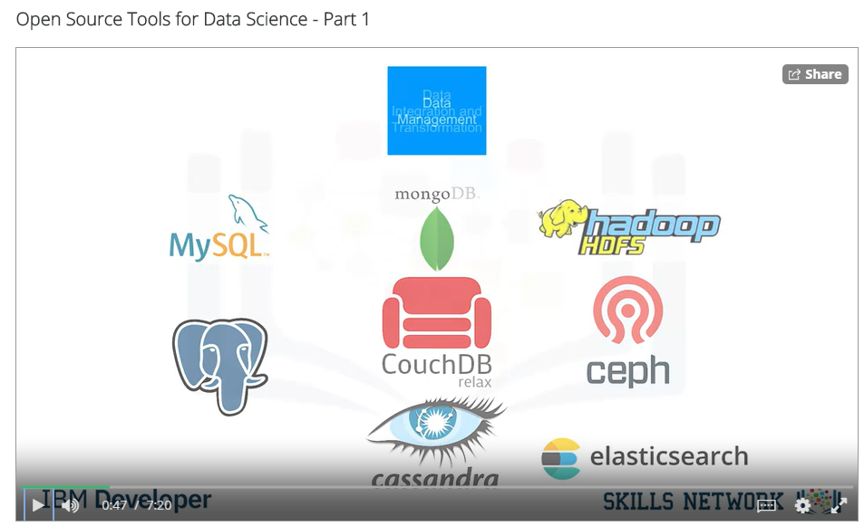

The most widely used open source data management tools are relational databases such as MySQL and PostgreSQL; NoSQL databases such as MongoDB Apache CouchDB, and Apache Cassandra; and file-based tools such as the Hadoop File System or Cloud File systems like Ceph. Finally, Elasticsearch is mainly used for storing text data and creating a search index for fast document retrieval.

Data integration (ETL or ELT)

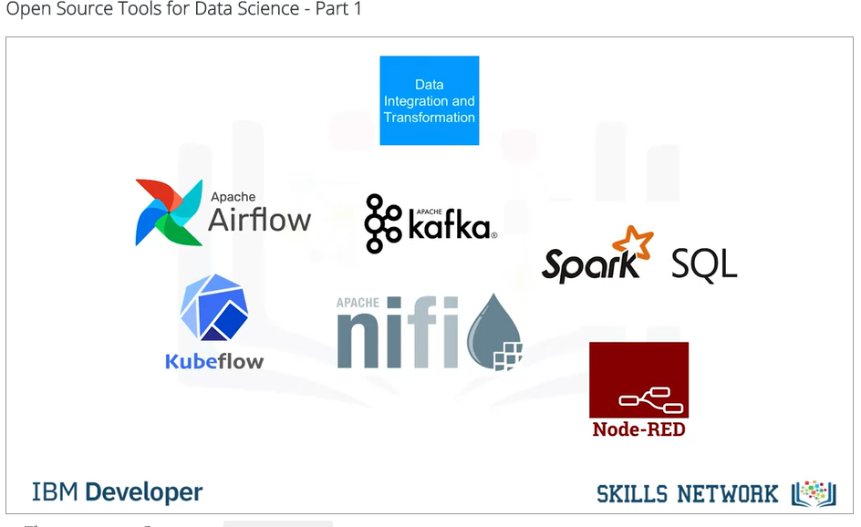

The task of data integration and transformation in the classic data warehousing world is called ETL, which stands for “extract, transform, and load.” These days, data scientists often propose the term “ELT” – Extract, Load, Transform“ELT”, stressing the fact that data is dumped somewhere and the data engineer or data scientist themself is responsible for data. Another term for this process has now emerged: “data refinery and cleansing.”

Here are the most widely used open source data integration and transformation tools: Apache AirFlow, originally created by AirBNB; KubeFlow, which enables you to execute data science pipelines on top of Kubernetes; Apache Kafka, which originated from LinkedIn; Apache Nifi, which delivers a very nice visual editor;

Apache SparkSQL (which enables you to use ANSI SQL and scales up to compute clusters of 1000s of nodes), and NodeRED, which also provides a visual editor.

NodeRED consumes so little in resources that it even runs on small devices like a Raspberry Pi.

Data visualization

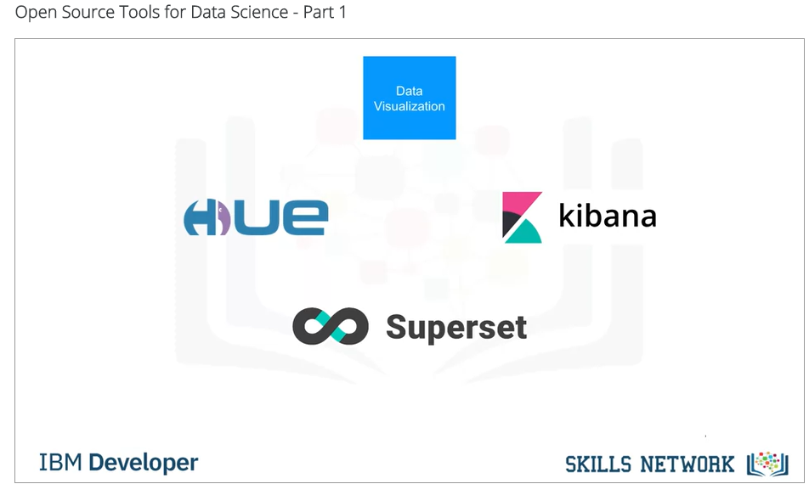

We’ll now introduce the most widely used open source data visualization tools.

We have to distinguish between programming libraries where you need to use code and tools that contain a user interface. The most popular libraries are covered in the next videos.A similar approach uses Hue, which can create visualizations from SQL queries. Kibana, a data exploration and visualization web application, is limited to Elasticsearch (the data provider). Finally, Apache Superset is a data exploration and visualization web application.

Model deployment

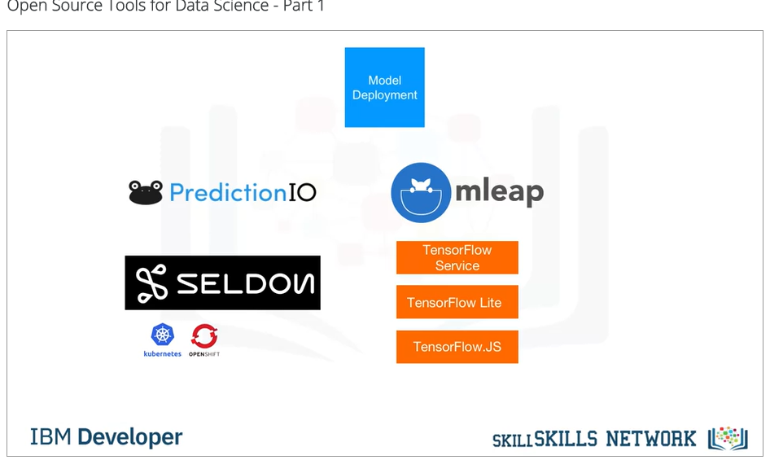

Model deployment is extremely important.

Once you’ve created a machine learning model capable of predicting some key aspects of the future, you should make that model consumable by other developers and turn it into an API.

Apache PredictionIO currently only supports Apache Spark ML models for deployment, but support for all sorts of other libraries is on the roadmap. Seldon is an interesting product since it supports nearly every framework, including TensorFlow, Apache SparkML, R, and scikit-learn.

Seldon can run on top of Kubernetes and Redhat OpenShift.  Another way to deploy SparkML models is by using MLeap.

Finally, TensorFlow can serve any of its models using the TensorFlow service. You can deploy to an embedded device like a Raspberry Pi or a smartphone using TensorFlow Lite, and even deploy to a web browser using TensorFlow dot JS.

Model monitoring

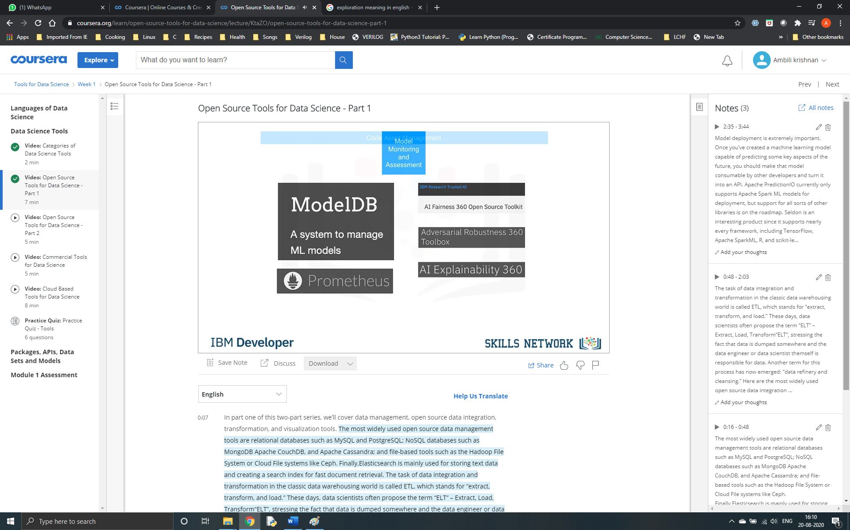

Model monitoring is another crucial step.

Once you’ve deployed a machine learning model, you need to keep track of its prediction performance as new data arrives in order to maintain outdated models.

Following are some examples of model monitoring tools:

ModelDB is a machine model metadatabase where information about the models are stored and can be queried. It natively supports Apache Spark ML Pipelines and scikit-learn. A generic, multi-purpose tool called Prometheus is also widely used for machine learning model monitoring, although it’s not specifically made for this purpose. Model performance is not exclusively measured through accuracy. Model bias against protected groups like gender or race is also important.

The IBM AI Fairness 360 open source toolkit does exactly this. It detects and mitigates against bias in machine learning models. Machine learning models, especially neural-network-based deep learning models, can be subject to adversarial attacks, where an attacker tries to fool the model with manipulated data or by manipulating the model itself.

The IBM Adversarial Robustness 360 Toolbox can be used to detect vulnerability to adversarial attacks and help make the model more robust. Machine learning modes are often considered to be a black box that applies some mysterious “magic.” The IBM AI Explainability 360 Toolkit makes the machine learning process more understandable by finding similar examples within a dataset that can be presented to a user for manual comparison. The IBM AI Explainability 360 Toolkit can also illustrate training for a simpler machine learning model by explaining how different input variables affect the final decision of the model.

Code Asset Management

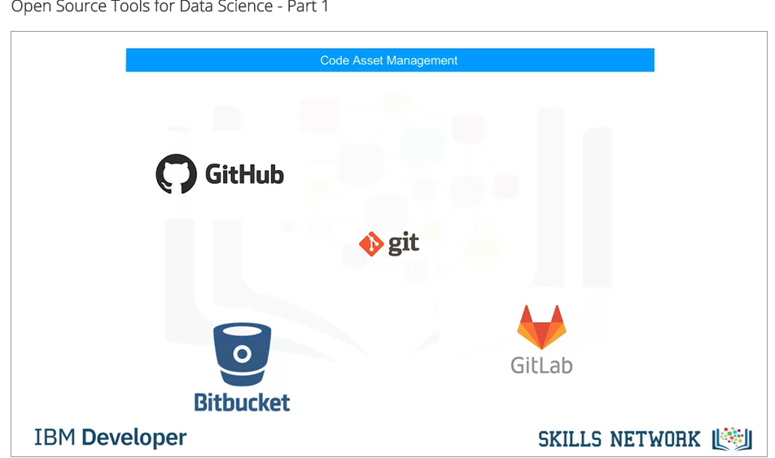

For code asset management – also referred to as version management or version control – Git is now the standard.

Multiple services have emerged to support Git, with the most prominent being GitHub, which provides hosting for software development version management.

The runner-up is definitely GitLab, which has the advantage of being a fully open source platform that you can host and manage yourself. Another choice is Bitbucket.

Data Asset Management

Data asset management, also known as data governance or data lineage, is another crucial part of enterprise grade data science. Data has to be versioned and annotated with metadata. Apache Atlas is a tool that supports this task.

Another interesting project, ODPi Egeria, is managed through the Linux Foundation and is an open ecosystem. It offers a set of open APIs, types, and interchange protocols that metadata repositories use to share and exchange data. Finally, Kylo is an open source data lake management software platform that provides extensive support for a wide range of data asset management tasks.

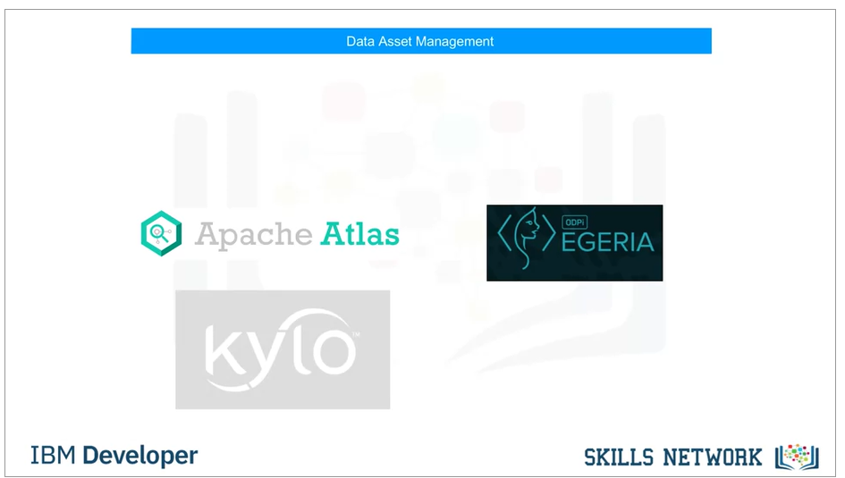

Development Environments

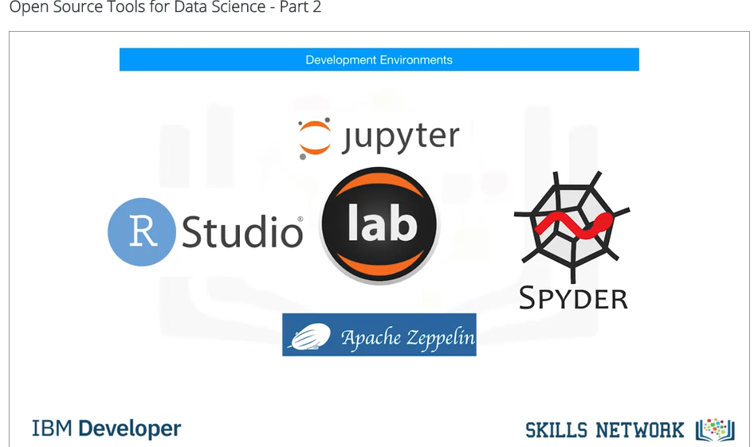

One of the most popular current development environments that data scientists are using is “Jupyter.” Jupyter first emerged as a tool for interactive Python programming; it now supports more than a hundred different programming languages through “kernels.”

Kernels shouldn’t be confused with operating system kernels. Jupyter kernels are encapsulating the different interactive interpreters for the different programming languages.

A key property of Jupyter Notebooks is the ability to unify documentation, code, output from the code, shell commands, and visualizations into a single document. JupyterLab is the next generation of Jupyter Notebooks and in the long term, will actually replace Jupyter Notebooks.

The architectural changes being introduced in JupyterLab makes Jupyter more modern and modular. From a user’s perspective, the main difference introduced by JupyterLab is the ability to open different types of files, including Jupyter Notebooks, data, and terminals. You can then arrange these files on the canvas.

Although Apache Zeppelin has been fully reimplemented, it’s inspired by Jupyter Notebooks and provides a similar experience. One key differentiator is the integrated plotting capability. In Jupyter Notebooks, you are required to use external libraries in Apache Zeppelin, and plotting doesn’t require coding. You can also extend these capabilities by using additional libraries.

RStudio is one of the oldest development environments for statistics and data science, having been introduced in 2011. It exclusively runs R and all associated R libraries.

However, Python development is possible and R is therefore tightly integrated into this tool to provide an optimal user experience. RStudio unifies programming, execution, debugging, remote data access, data exploration, and visualization into a single tool.

Spyder tries to mimic the behaviour of RStudio to bring its functionality to the Python world. Although Spyder does not have the same level of functionality as RStudio, data scientists do consider it an alternative. But in the Python world, Jupyter is used more frequently.

Execution environments

Sometimes your data doesn’t fit into a single computer’s storage or main memory capacity. That’s where cluster execution environments come in. The well known cluster-computing framework Apache Spark is among the most active Apache projects and is used across all industries, including in many Fortune 500 companies.

The key property of Apache Spark is linear scalability. This means, if you double the number of servers in a cluster, you’ll also roughly double its performance.

After Apache Spark began to gain market share, Apache Flink was created. The key difference between Apache Spark and Apache Flink is that Apache Spark is a batch

data processing engine, capable of processing huge amounts of data file by file. Apache Flink, on the other hand, is a stream processing image, with its main focus on processing real-time data streams. Although engine supports both data processing paradigms, Apache Spark is usually the choice in most use cases.

One of the latest developments in the data science execution environments is called “Ray,” which has a clear focus on large-scale deep learning model training.

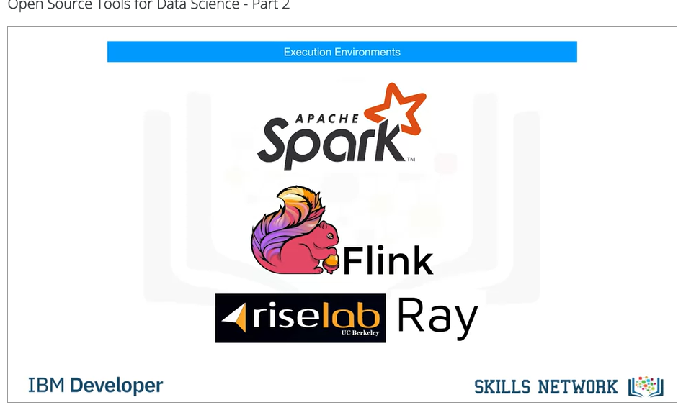

Fully integrated and visual open source tools

Let’s look at open source tools for data scientists that are fully integrated and visual.

With these tools, no programming knowledge is necessary. Most important tasks are supported by these tools; these tasks include data integration, transformation, data visualization, and model building.

KNIME originated at the University of Konstanz in 2004.

As you can see, KNIME has a visual user interface with drag-and-drop capabilities.

It also has built-in visualization capabilities. Knime can be be extended by programming in R and Python, and has connectors to Apache Spark.

Another example of this group of tools is Orange. It’s less flexible than KNIME,

**Commercial tools for Data Science**

Data Management

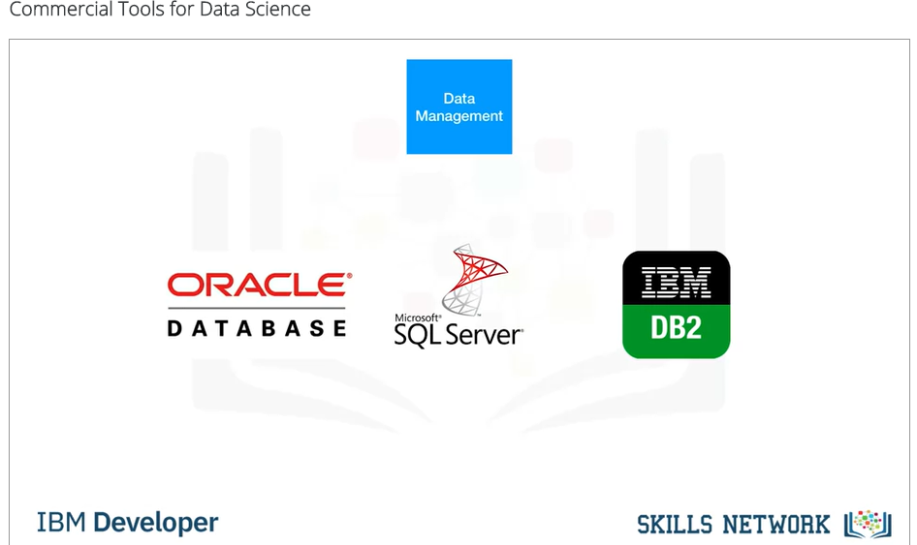

In data management, most of an enterprise’s relevant data is stored in an Oracle Database, Microsoft SQL Server, or IBM Db2.

Although open source databases are gaining popularity, those three data management products are still considered the industry-standard. They won’t disappear in the near future. It’s not just about functionality. Data is at the heart of every organization, and the availability of commercial supports plays a major role. Commercial supports are delivered directly from software vendors, influential partners, and support networks.

Data Integration Tools (ETL)

According to a Gartner Magic Quadrant, Informatica Powercenter and IBM InfoSphere DataStage are the leaders, followed by products from SAP, Oracle, SAS, Talend, and Microsoft.

These tools support design and deployment of ETL data-processing pipelines through a graphical interface. They also provide connectors to most of the commercial and open source target information systems.

Finally, Watson Studio Desktop includes a component called Data Refinery, which enables the defining and execution of data integration processes in a spreadsheet style.

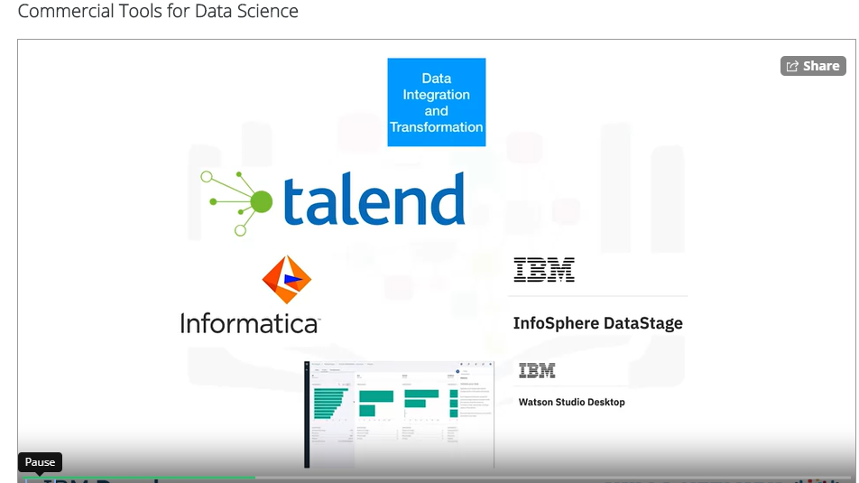

Data visualization

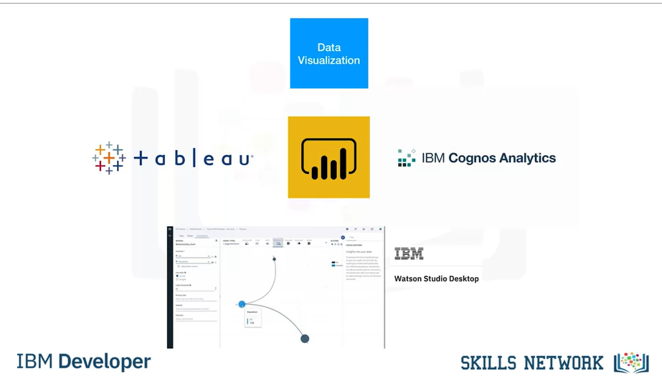

In the commercial environment, data visualizations are utilizing business intelligence, or “BI”, tools. Their main focus is to create visually attractive and easy-to-understand reports and live dashboards. The most prominent commercial examples are: Tableau, Microsoft Power BI, and IBM Cognos Analytics. Another type of visualization targets data scientists rather than regular users. A sample problem might be “How can different columns in a table relate to each other?” This type of functionality is contained in Watson Studio Desktop.

Model Building

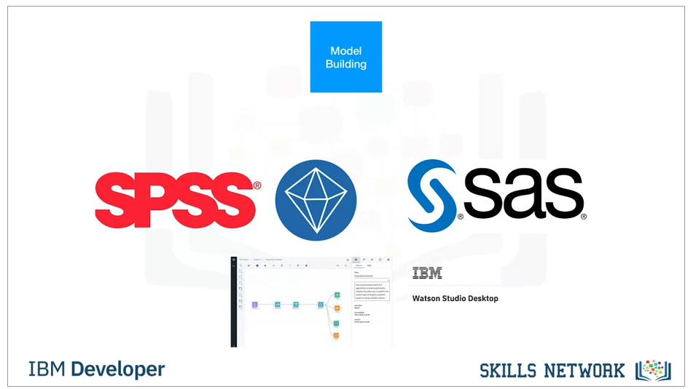

If you want to build a machine learning model using a commercial tool, you should consider using a data mining product. The most prominent of these types of products are: SPSS Modeler and SAS Enterprise Miner. In addition, A version of SPSS Modeler is also available in Watson Studio Desktop, based on the cloud version of the tool.

Model Deployment

This diagram shows an example of the SPSS Collaboration and Deployment Services which are used to deploy any type of asset created by the SPSS software tools suite.

Other vendors use the same type of process. Commercial software can also export models in an open format. For example, SPSS Modeler supports the exporting of models as Predictive Model Markup Language, or PMML, which can be read by many other commercial and open software packages.

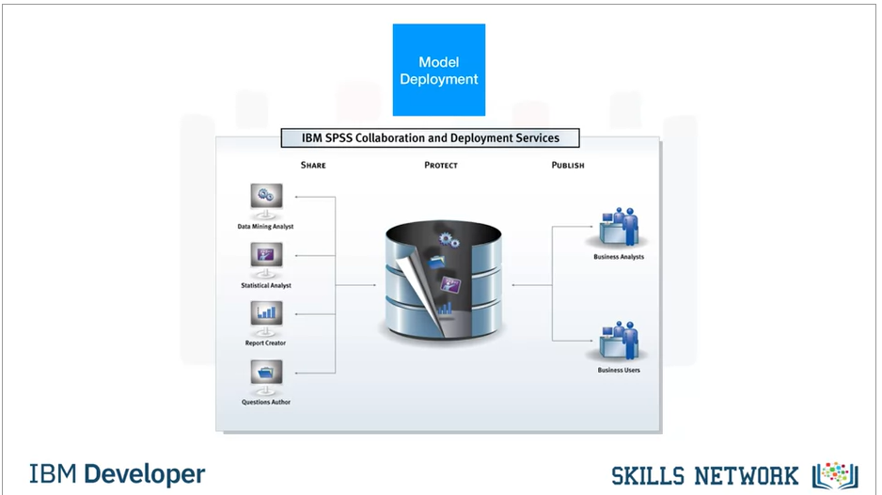

Model monitoring and assessment . Code Asset Management

Model monitoring is a new discipline and there are currently no relevant commercial tools available. As a result, open source is the first choice. The same is true for code asset management. Open source with Git and GitHub is the effective standard.

Data Assessment

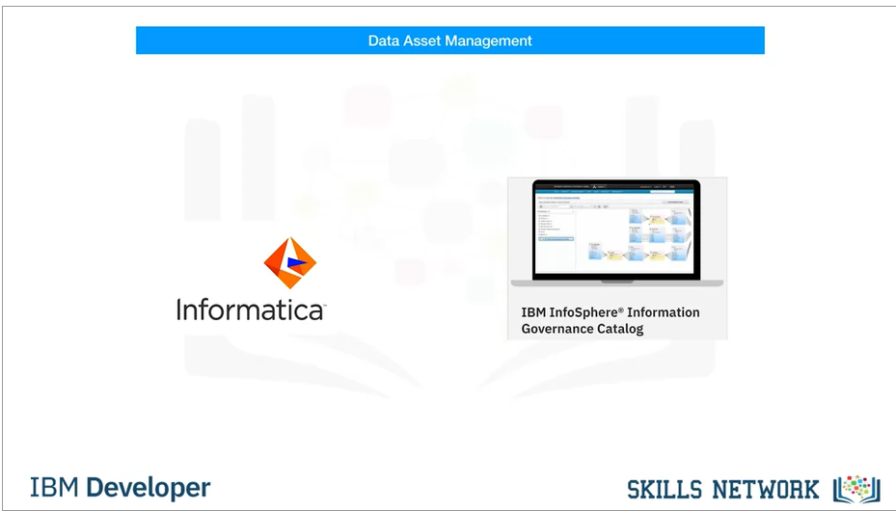

Data asset management, often called data governance or data lineage, is a crucial part of enterprise grade data science. Data must be versioned and annotated using metadata. Vendors, including Informatica Enterprise Data Governance and IBM, provide tools for these specific tasks.

The IBM InfoSphere Information Governance Catalog covers functions like data dictionary, which facilitates discovery of data assets. Each data asset is assigned to a data steward -- the data owner. The data owner is responsible for that data asset and can be contacted. Data lineage is also covered; this enables a user to track back through the transformation steps followed in creating the data assets. The data lineage also includes a reference to the actual source data. Rules and policies can be added to reflect complex regulatory and business requirements for data privacy and retention.

Development Environment

Watson Studio is a fully integrated development environment for data scientists. It’s usually consumed through the cloud. There is also a desktop version available. Watson Studio Desktop combines Jupyter Notebooks with graphical tools to maximize data scientists’ performance.

Fully Integrated Visual Tools

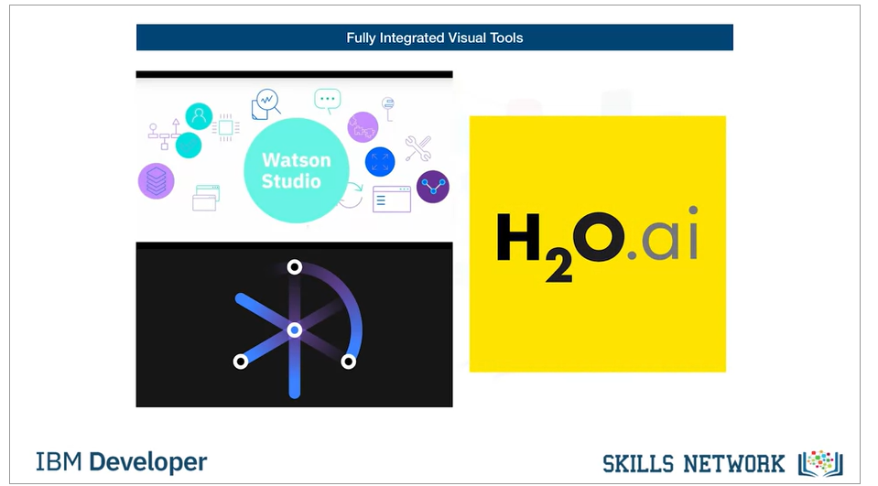

Watson Studio, together with Watson Open Scale, is a fully integrated tool covering the full data science life cycle and all the tasks we’ve discussed previously.

Another example of a fully integrated commercial tool is H2O Driverless AI, which covers the complete data science life cycle.

Cloud based tools for data science

Fully integrated visual tools category

Since cloud products are a newer species, they follow the trend of having multiple tasks

integrated in tools.

This especially holds true for the tasks marked green in the diagram.

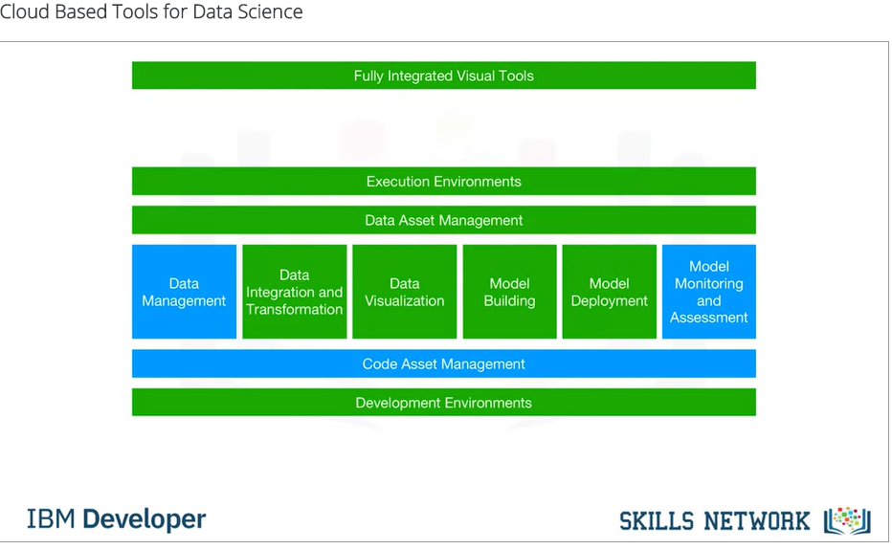

Let’s start with the fully integrated visual tools category.

Since these tools introduce a component where large scale execution of data science workflows

happens in compute clusters, we’ve changed the title here and added the word “Platform.”

These clusters are composed of multiple server machines, transparently for the user, in the

background.

Watson Studio, together with Watson OpenScale, covers the complete development life cycle

for all data science, machine learning, and AI tasks.

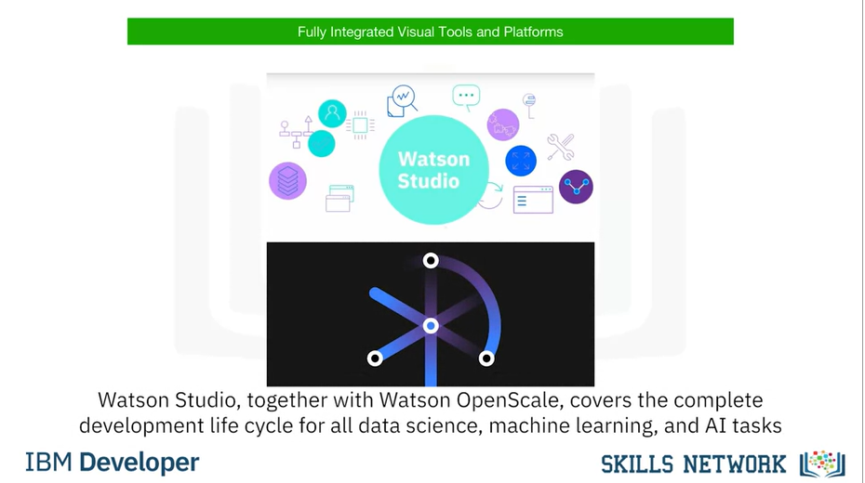

Another example is Microsoft Azure Machine Learning.

This is also a fully cloud-hosted offering supporting the complete development life cycle

of all data science, machine learning, and AI tasks.

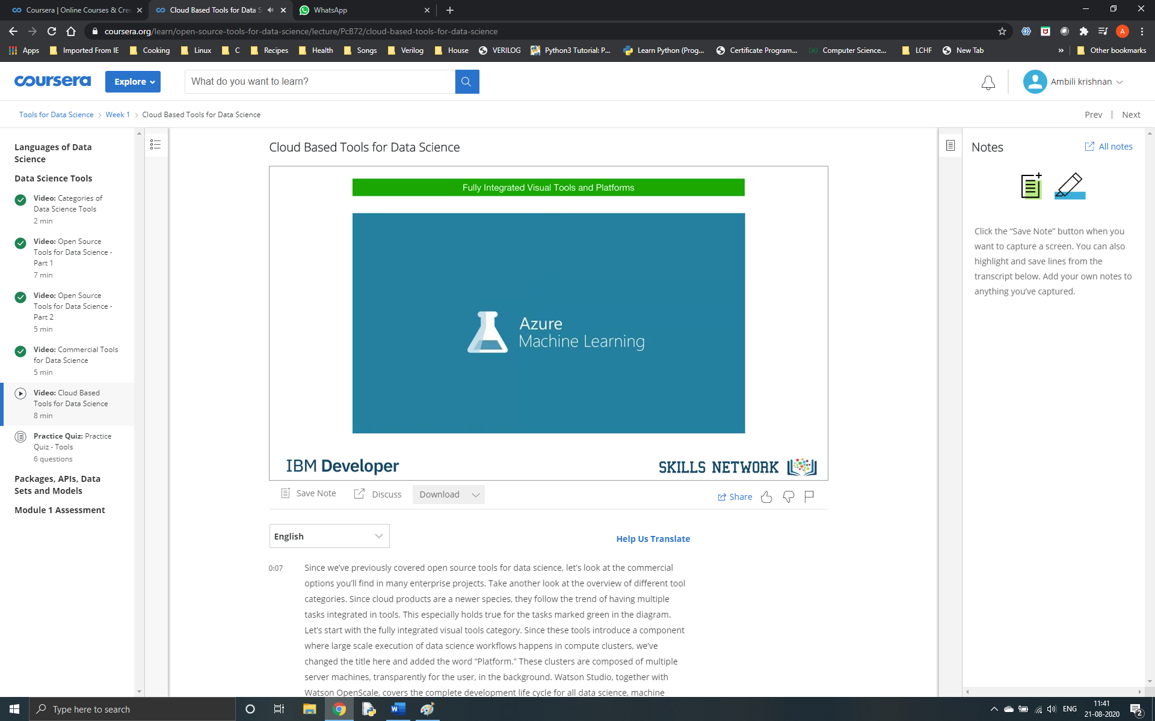

And finally, another example is H2O Driverless AI, which we’ve already introduced in the

last video.

Although it is a product that you download and install, one-click deployment is available

for the common cloud service providers.

Since operations and maintenance are not done by the cloud provider, as is the case with

Watson Studio, Open Scale, and Azure Machine Learning, this delivery model should not be

confused with Platform or Software as a Service -- PaaS or SaaS.

Paas : Platform as a service

Saas – Software as a service

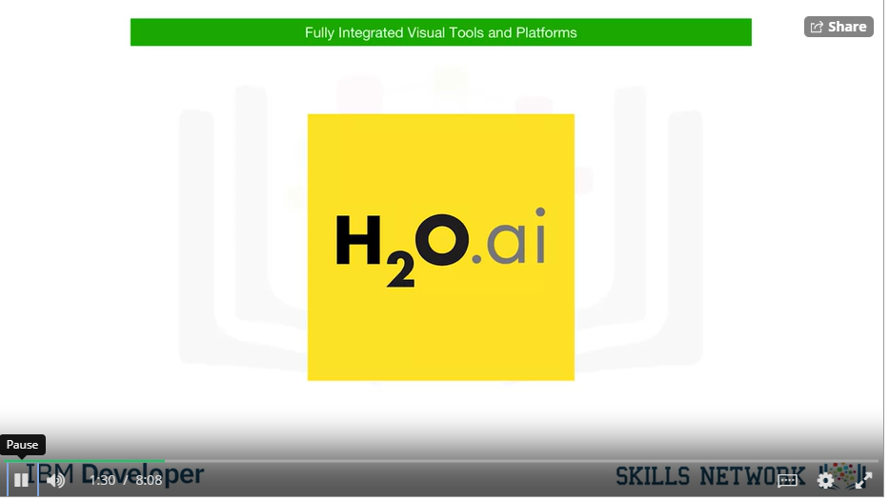

Data Management

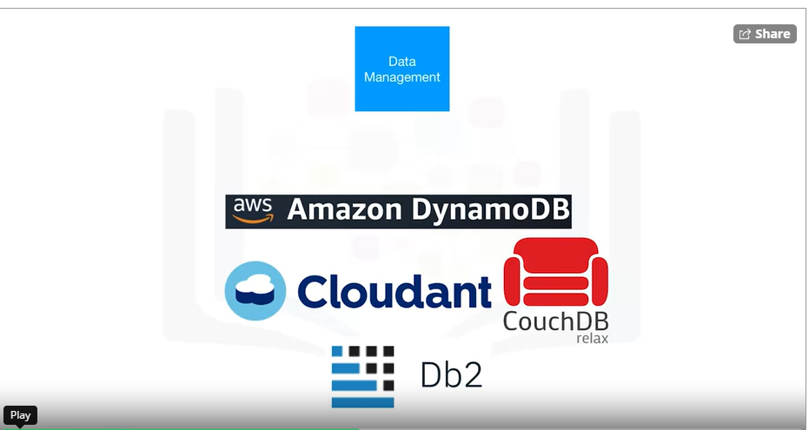

In data management, with some exceptions, there are SaaS versions of existing open source

and commercial tools.

Remember, SaaS stands for “software as a service.”

It means that the cloud provider operates the tool for you in the cloud.

As an example, the cloud provider operates the product by backing up your data and configuration

and installing updates.

As mentioned, there is proprietary tooling, which is only available as a cloud product.

Sometimes it’s only available from a single cloud provider.

One example of such a service is Amazon Web Services DynamoDB, a NoSQL database that allows

storage and retrieval of data in a key-value or a document store format.

The most prominent document data structure is JSON (pronounced “jay-sun”).

Another flavour of such a service is Cloudant, which is a database-as-a-service offering.

But, under the hood it is based on the open source Apache CouchDB.

It has an advantage: although complex operational tasks like updating, backup, restore, and

scaling are done by the cloud provider, under the hood this offering is compatible with

CouchDB.

Therefore, the application can be migrated to another CouchDB server without changing

the application.

And IBM offers Db2 as a service as well.

This is an example of a commercial database made available as a software-as-a-service

offering in the cloud, taking operational tasks away from the user.

Data integration tools

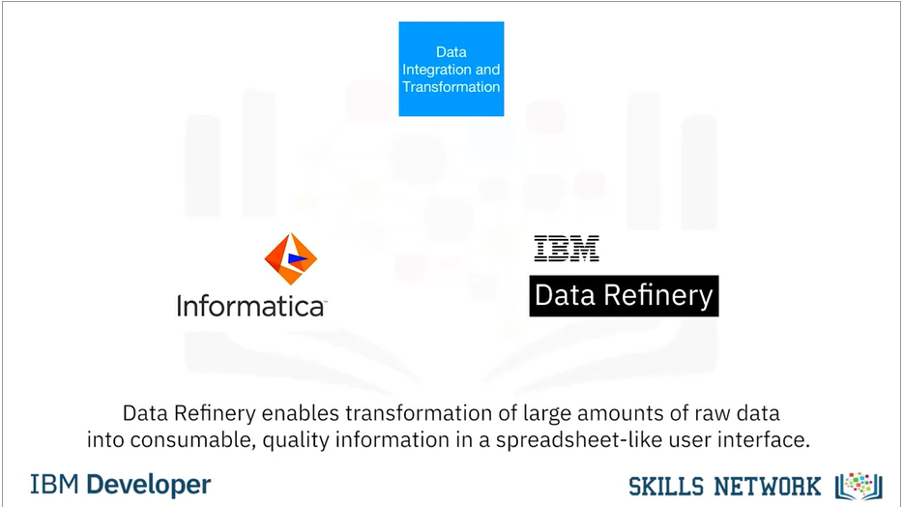

When it comes to commercial data integration tools, we talk not only about “extract,

transform, and load,” or “ETL” tools, but also about “extract, load, and transform,”

or “ELT,” tools.

This means the transformation steps are not done by a data integration team but are pushed

towards the domain of the data scientist or data engineer.

Two widely used commercial data integration tools are Informatica Cloud Data Integration

and IBM’s Data Refinery.

Data Refinery enables transformation of large amounts of raw data into consumable, quality

information in a spreadsheet-like user interface.

Data Refinery is part of IBM Watson Studio.

Data Visualization

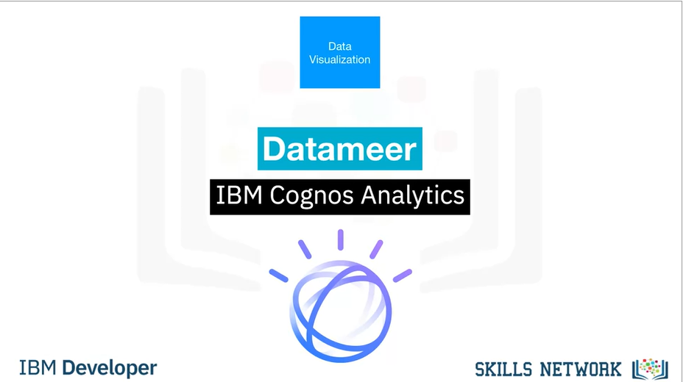

The market for cloud data visualization tools is huge, and every major cloud vendor has

one.

An example of a smaller company’s cloud-based data visualization tool is DataMeer.

IBM offers it’s famous Cognos Business intelligence suite as cloud solution as well.

IBM Data Refinery also offers data exploration and visualization functionality in Watson

Studio.

Again, these are just some examples of a rapidly changing and growing commercial ecosystem

among a huge number of established and emerging vendors.

Model Building

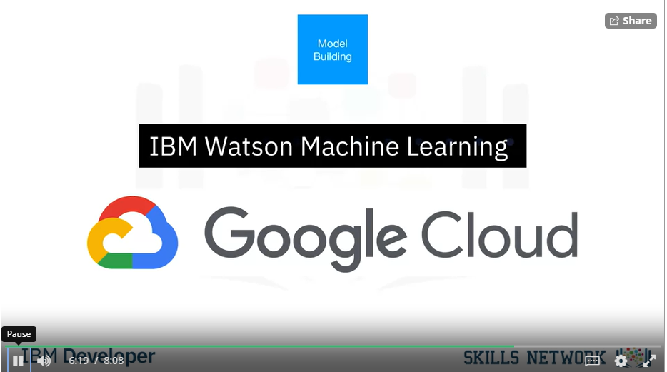

Model building can be done using a service such as Watson Machine Learning.

Watson Machine Learning can train and build models using various open source libraries.

Google has a similar service on their cloud called AI Platform Training.

Nearly every cloud provider has a solution for this task

Model Deployment

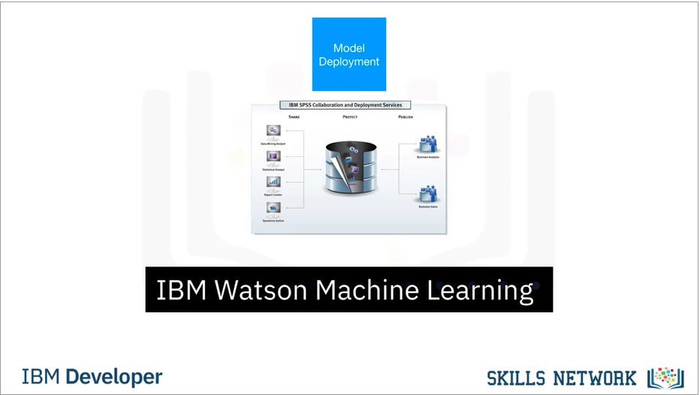

Model deployment in commercial software is usually tightly integrated to the model building

Model monitoring and assessment

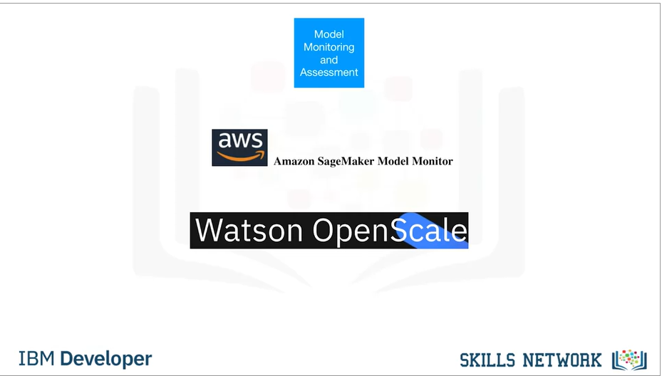

Watson OpenScale.

OpenScale and Watson Studio…

…unify the landscape.

Everything marked in green can be done using Watson Studio and Watson OpenScale.

